Instructions Page 1
(Please do not send print of Instruction pages along with PF withdrawal Form 19)
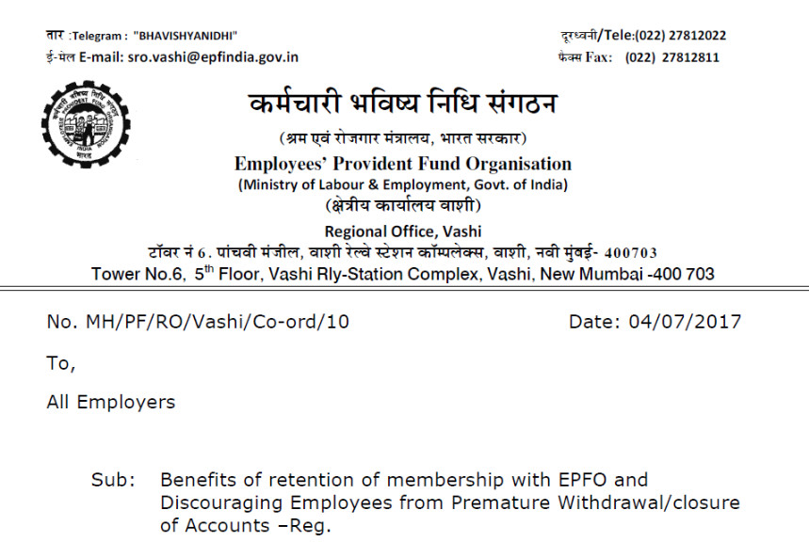
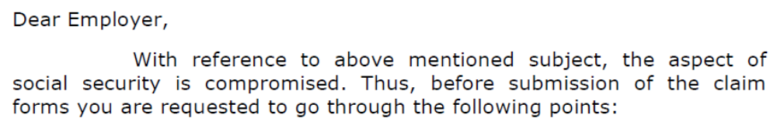
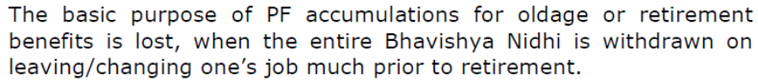
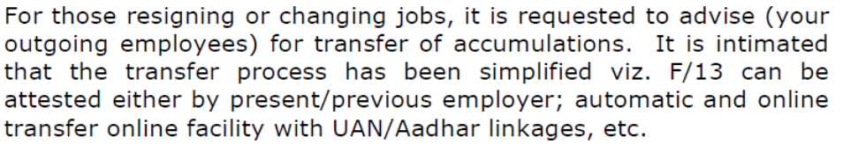
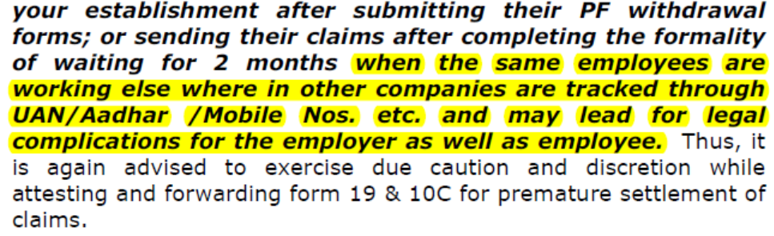
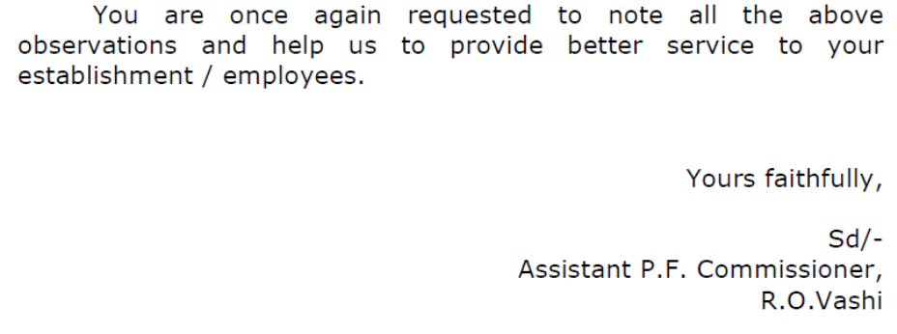

Instructions Page 2

PF withdrawal form needs to be filled and couriered to Hexaware PF Trust address.

- Member is eligible to withdraw PF only in case of unemployed, i.e. after 2 months from the Last Working Day in the organization.

- Kindly arrange to submit declaration on Non-employment for last 60 days.

- In case of Migration, member can apply for withdrawal on last working day subject to a copy of Visa & Passport or immediately on receipt of Visa. Copy of visa and passport is mandatory in case of Migration.

- The PF withdrawal amount will be taxable if member have worked in the organization for less than 5 years.

- Application date should be after 2 months from the date of leaving the organization.

- PAN (Permanent Account No) is mandatory. Please attach copy of PAN.

- PF A/c No. is mentioned in your Salary Slip.

- The PF amount would be cleared in approximately 45-60 days from the date of receipt of form by PF Trust.

- Please provide your contact address, Email id and contact number so that the PF dept can get back to you incase of any issue/query.

- Please affix Rs.1/- revenue stamp and sign across the stamp in Advance Stamped Receipt.

- Please attach cancelled Cheque leaf & copy of Pass Book or latest bank statement if name is not printed on cheque leaf with Application Form.

PF WITHDRAWAL FORM – 19

Hexaware Technologies Ltd. Employees’ Provident Fund
#152, Millennium Business Park, Sector-3, A – Block, TTC Industrial Area, Mahape, Navi Mumbai – 400 710.
Tel: +91-22-6756 1003 e mail: pfhelp@hexaware.com Fax: 91-22-2778 2322
(Application form for claiming Provident Fund dues)

The Trustees
Hexaware Technologies Ltd. Employees’ Provident Fund.

I hereby request you to pay me the full amount standing to my credit in the Fund after making such deductions as may be authorised under the scheme. Relevant details are furnished below:

- Name (Full name in block letters ): MOHAMED IBRAHIM

- Father Name : MOHAMED ABDUL KADAR

- Residential Status : NRI
- Residential Address : 9210, DEERCROSS PARKWAY, APT 1B, BLUE ASH, OHIO-45236
*Mob. No. +1-8643459595 *E mail ID: IBBU071985@GMAIL.COM
4. Date of Birth : 16-JUL-1985 Permanent Account No. (PAN) _______________ _______ __
(Please attach copy of PAN Card)
- Employee Number: 24246 6. PF account number : TH/VSH/42123/000 /20165

7. Date of joining service: 18-Apr-2012 8. Date of leaving service: 6-May-2019

- Reason for leaving service : Migration

- Bank Details: (i) Savings A/c No.: 20305543691 ,(ii) Bank Name: STATE BANK OF INDIA
(iii)Branch Address: SNO.637/2, OMR ROAD, PADUR VILLAGE AND POST, DISTT.KANCHEEPURAM. TAMIL NADU-603103, IFSC Code: SBIN0017181
I declare that I have not been employed in any factory / establishment to which E P F & M P Act applies for a continuous period of not less than (Two months) immediately preceding the date of my application for final withdrawal of my P F dues.

Date : Signature of the Employee
Note: 1. Withdrawal is allowed only in case of unemployed after 60 days from the date of leaving.
2. PF withdrawal is subject to deduction of Tax.

ADVANCE STAMPED RECEIPT
(The space should be left blank which shall be filled by the Trust)
Received a sum of Rs._____________ (Rupees_________________________________ ________________________________) from Hexaware Technologies Ltd. Employees’ Provident Fund towards full and final settlement of my PF dues. Cheque No. ______________ Date: _______________ Drawn on: ________________
Rs.1/- Revenue Stamp

(Signature of the employee (Please affix an Rs.1/- Revenue stamp & sign across it)

NON EMPLOYMENT CERTIFICATE
SELF DECALARATION BY THE MEMBER / CLAIMANT

I MOHAMED IBRAHIM S/o MOHAMED ABDUL KADAR residing at 9210, DEERCROSS PARKWAY, APT 1B, BLUE ASH, OHIO-45236 do hereby solemnly affirm and sincerely state as here under:

I MOHAMED IBRAHIM S/o MOHAMED ABDUL KADAR declare that I was an employee of Hexaware Technologies Ltd bearing UAN & PF A/c no. 100228894450 and left the Job on 6-May-2019 and that I/My Husband / Wife had not been employed in any other establishment covered under the EPF scheme, 1952, prior to the date of Joining the establishment / after the date of leaving service from the above establishment.

And that I declare that I am not in receipt of any pensionary benefits under Employees Family Pension 1971 / Employees’ Pension Scheme 1995. That what is stated above is true and correct to the test of My Knowledge.

In case, my above declaration is found to be false, I undertake to return the PF & Pension in full with interest as declared by the EPF organisation and I am liable for any action that may be initiated by EPFO in this regard.

Solemnly affirmed at (Place) Date:

Signature:
Name:
Address:

